Accessing Course Content Using GitHub

Overview
Most files for this course this semester will be shared using a synchronized course filesystem known as a GitHub repository. Our course repository (or repo) is located on GitHub.com and is structured as follows (or close to this):

info_sys_course/
├── ADMIN/
├── LEC/
│ ├── LEC_1
│ ├── LEC_2
│ └── …
├── HW/
│ ├── HW_1
│ ├── HW_2
│ └── …
├── EXAMS/
├── QUIZZES/
├── REFERENCES/
└── README.md
- You will clone (copy down to your machine) this repo once at the beginning of the course.
- The repo will be updated frequently with new files and updates to files as necessary.
- You will pull updates from this repo regularly.
  - With one command, you will receive all updates to the repo.
  - You should get in the habit of pulling whenever you sit down to work on this course. I will aim to notify you whenever I update the repo.
  - We may even do updates within a class period this way.
- Your local repo folders should have the structure shown above (or be very similar to it) once you pull.
- Never edit files in this repo*.
  - Treat the course repo as “read-only content”.
  - You will create a parallel folder where you can edit files. Your work should live in files you create, not the course repo files. If you accidentally edit a file in the repo, see the fix below.
  - * The one exception is that you can create and edit files in the student_work folder.
- Advantages to this system include:
  - no downloading of individual files
  - no clicking through Canvas screens
  - reduced decision making on where to place files on your end
  - resembles industry practice in collaborative software development (see below)

Student workflow
The steps below can be performed with either of two tools (that I will support).
- GitHub Desktop
- use this if you want a friendlier, windows-based approach
- installed from https://desktop.github.com/download/
- Git from the terminal
- e.g. Git Bash, Anaconda PowerShell, regular PowerShell, terminal etc.
- use this if you want more of the “power user” experience
- to see if it is already installed, type git –version in the terminal; if not install Git for Windows: https://git-scm.com/download/win

Step 1: Create a GitHub account if you do not already have one by going to GitHub.com.

Step 2: Log in to your GitHub account in your tool of choice:
- Log in using GitHub Desktop
Sign into your GitHub account by going to File:Options:Accounts.
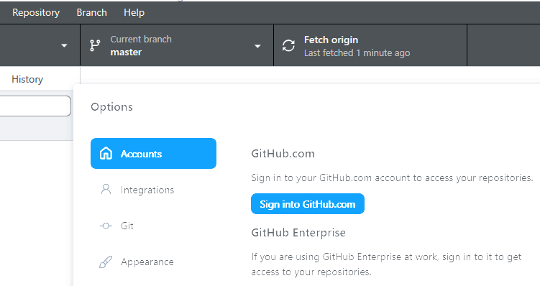
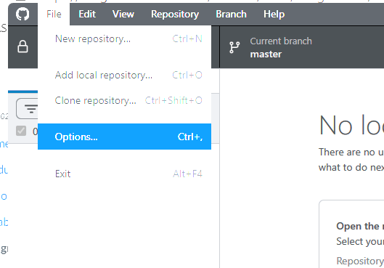
- Log in using Git from the terminal
Type:
git config --global user.name "Your Name"
git config --global user.email your_email@example.com
Use the same email address you use for your GitHub account.
The first time Git needs access to GitHub, it will open a browser or prompt you to authenticate. After that, your computer should remember your credentials.

Step 3: Clone the info_sys_course repo
Do this once at the beginning of the course (but also later if you have issues – see below).
- Clone the repo using GitHub Desktop

  - Click the down arrow next to “Current repository” (top left)
  - Click “Add”, then “Clone repository”
  - Click “URL” then type: https://github.com/prof-frommer/info_sys_course
(Note there are underscores “_” between info, sys, and course.)
You can set the local folder where the files will be stored by clicking “Choose…”
  - Click “Clone”

- Clone the repo using Git from the terminal

- Open your Terminal, Git Bash, etc.
- Navigate to the directory where you want the project folder to be created (e.g., cd Documents/Courses).
- Type:
git clone https://github.com/prof-frommer/info_sys_course.git
You will then have a local folder:
info_sys_course/ ← read-only course materials

Step 4: Create a separate working directory for your working files
You can create this directory anywhere you would like other than within the repo. For example, you can create it right next to the repo:
info_sys_course/ ← Your local copy of the repo, DO NOT EDIT
course_work/ ← EDIT FREELY, name however you wish
You can copy files from the local repo to work on them using Windows explorer or in the terminal, e.g.:
cp -r info_sys_course/LEC/class_03/ course_work/LEC/class_03

Alternatively, just open files and “Save As” into course_work.

Step 5. Regularly update the repo by pulling:
- Pull using GitHub Desktop
- Making sure the “Current repository” on the upper left is set to the course repo, click the “Fetch origin” button on top right.

- If there are updates to be pulled, you will see a “Pull Origin” button appear after fetching the repo just below the “Fetch origin” button. Click that button and that should complete the pull.

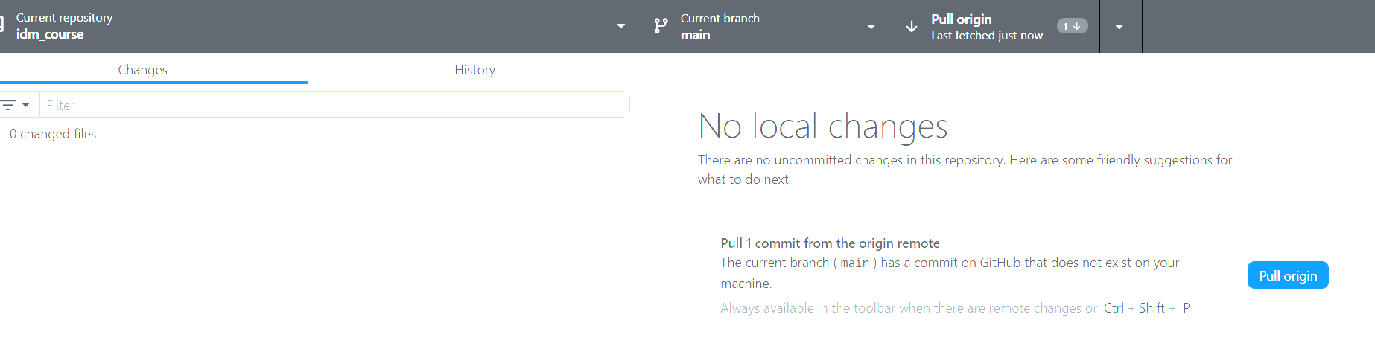
- Pull using Git from the Terminal
- Open Terminal, Git Bash, etc.
- Navigate into the local directory of your existing repository, e.g. cd info_sys_course
- type: git pull

What to do if something goes wrong
You may find that you have inadvertently edited/added/deleted a file in the repo, git pull is not working or not even an option, you see a message about not having writing access asking if you want to create a fork, etc. Do not worry - you can undo the damage through one of the following two methods.
Notes:
- If you created files inside the repo’s student_work/ folder, these are safe; git will not delete them
- If a git pull fails while you have a Word, PowerPoint, or Excel file open from the course repo, save and close the file and try again. (Or copy the file outside the repo to have it open for editing.)
- Discard changes – this more “surgical” method is preferred
- Discard changes using GitHub Desktop:
  - Look at list of changed files under “Changes” tab on left side of GitHub Desktop.
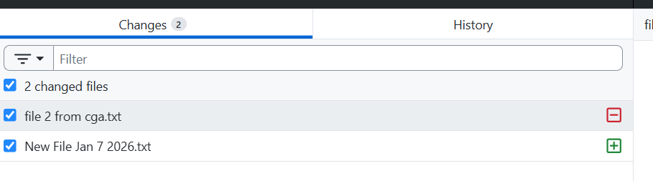
  - If you want to keep copies of these files, find them in Windows explorer and copy them to a folder outside of the repo.

  - Discard changes you made to any of the course repo files in GitHub desktop.
    - Select the files one or many at a time
    - Right click on the selected file(s) and click “Discard selected changes…”
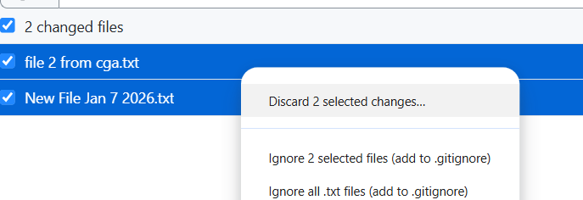
  - You should now be able to pull again.

- Discard changes using Git from the terminal
- At the top level directory of the local repo, verify you changed repo file(s) by typing:
git status
You should see something like:

Changes not staged for commit:
modified: LEC/Day 3/brewery_skeleton.py

where the file or files next to modified will be the ones you changed.
- Type: git restore .
- Do not leave off the “.”
- This restores the most recent version of the course repo.
Alternatively, if you know you only changed one file, you can restore just that file (or repeat this for a small number of files) by typing:
git restore “LEC/Day 3/brewery_skeleton.py”
- Typing git status again should show:
nothing to commit, working tree clean
- Now you are safe to pull updates again, using git pull

- “Nuke and Reclone”
  - If you have added any files you wish to keep, back them up or back up the entire repo first (e.g. by copying the entire folder to someplace else).
  - Delete the repo folder and all its contents from Windows explorer (or you can do this from the terminal using: rm -rf info_sys_course)
  - Now you should be safe to reclone – see instructions on cloning above.

Ask for help if:
- Git shows messages you do not understand
- you think your work might be lost
- you are unsure which files are yours, and/or
- you have other questions or concerns
That’s normal. It happens to professionals too. I expect all students to be able to get this to work. If you are adamantly opposed to it, I can provide you with a much less effective non-GitHub way to obtain the course content using downloads of zip files.
Remember:
- If you add your own files to the repo other than in the student_work folder, this will cause a conflict preventing you from being able to pull.
- You are free to put your own files in the student_work folder within the repo. (I do not plan to put files in there other than the readme.md file and the .gitkeep file, both of which you should leave untouched.)
- You will not have write privileges to this course repo, so you will not be pushing files to it at any point.
- It is always good practice to back up your work regularly. For example, you could zip up your student_work folder each week and copy it somewhere safe.
Summarizing:
- One repo
- Clone once
- Pull often
- Never edit repo files
- Work next door

Optional reading - more on the why
Our set-up maps very cleanly onto real-world, common professional workflows, especially in environments where content is centrally owned, updates are frequent, not everyone has write access, you can clone a repo but not push to it since you build on top of existing code without modifying it, and safety matters more than flexibility. These kinds of environments are quite common, e.g. internal libraries owned by other departments/teams, external vendor APIs, research codebases, etc. The regular, frequent updates to our repo resemble these practices in industry: fast-moving repos; daily merges; fast, urgent fixes to production code (aka hotfixes); evolving APIs; and more. In those environments, developers pull often, avoid local modifications, and expect change.
Later on, you will likely see many more aspects of Git including forks (for ownership of work), branches (for trying out new features), merging, resolving conflicts, pull requests (PR), etc.

